Enhancement of Laser Ablation via Interacting Spatial Double-pulse Effect
Rui ZHOU^{a, *}, Shengdong LINª, Ye DING^{b, c}, Huan YANG^{b, d}, Kenny Ong Yong Keng^{b} and Minghui HONG^{b, *}
ªDepartment of Mechanical and Electrical Engineering, School of Aerospace Engineering, Xiamen University, Xiamen, Fujian Province, China 361102
^{b}Department of Electrical and Computer Engineering, National University of Singapore, Singapore 117576
^{c}School of Mechatronics Engineering, Harbin Institute of Technology, Harbin , Heilongjiang Province, China 150001
^{d}College of Mechanical and Electrical Engineering, Wenzhou University, Wenzhou, Zhejiang Province, China 325035
* rzhou2@xmu.edu.cn, elehmh@nus.edu.sg
Rui ZHOU, Department of Mechanical and Electrical Engineering, School of Aerospace Engineering, Xiamen University, Xiamen, Fujian Province, China 361102, rzhou2@xmu.edu.cn.
Minghui HONG, Department of Electrical and Computer Engineering, National University of Singapore, Singapore 117576, elehmh@nus.edu.sg

Appendices
Fig. S1 shows the influence of double-pulse gap on the ablation efficiency and quality of grooves. By processing parallel grooves, the effect of interactive double laser pulses can be demonstrated clearly as well. Only shallow grooves and a large number of particles are produced with a large gap, such as 100 μm in Fig. S1(a). In this process of laser ablation, the melting of materials is dominant due to low laser fluence. Hence, a large number of particles are scattered in the laser scanning area. The grooves are not obvious and the material is not significantly removed. When the gap is decreased to 40 μm as shown in Fig. S1(b), two narrow grooves are merged into a wider one due to the interacting double laser pulses. Although melting is still dominant, the amount of evaporated material is also increasing. More materials can be ejected from groove, leading to the increasing depth of the groove. The amount and size of particles become more and larger due to higher laser fluence. However, the quality of processed groove is still unsatisfactory. When the gap further decreases to 20 μm, greater change occurs. As can be seen in Fig. S1(c), an obvious groove is fabricated with larger depth and width. There are only a few protrusions at the bottom, indicating better ablation quality. This process is dominated by laser evaporating materials piled up on the edge of grooves. Most materials are ejected from laser scanning area, leaving a deep and wide groove with a relatively flat bottom. If the gap disappears, the depth and width decrease with more debris stacking surrounding regions of the groove as observed in Fig. S1(d). The protrusions at the bottom of the groove increase a lot, indicating reduced ablation quality. As a contrast, a single beam laser is also used to process a groove which is shown in Fig. S1(e) for better comparison. There is no much difference between grooves processed by single beam laser in Fig. S1(e) and double pulse laser without gap in Fig. S1(d), although there exists slight difference in the size of debris stacking surrounding regions of the groove, which may be attributed to the overlapping loss of double laser pulses. By comparing different grooves, it is observed that double pulse laser with 20 μm has the largest laser ablation rate and the quality of the as-processed grooves is optimized with less protrusions and debris.

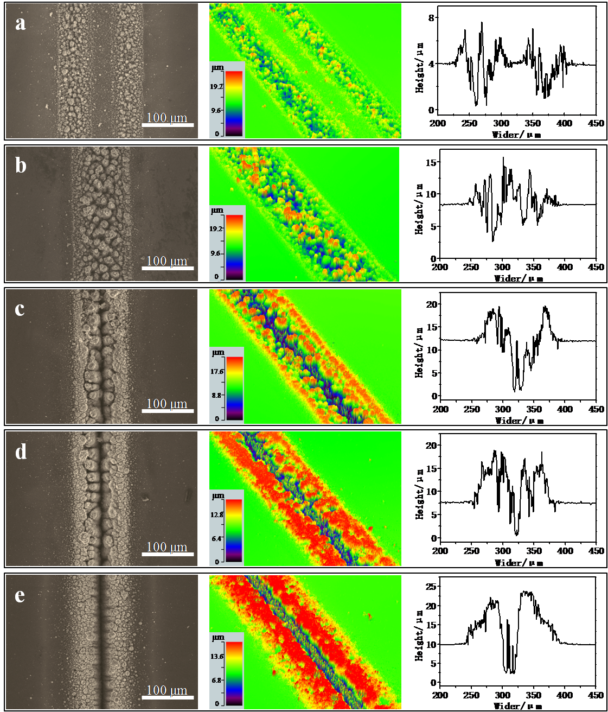
Fig. S1. SEM images, 3D reconstructions and 2D profiles of grooves processed by double laser pulses with different gaps of (a) 100 μm; (b) 40 μm; (c) 20 μm; (d) 0 μm and (e) single laser.

